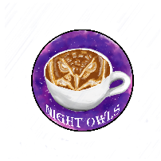 ***Night Owls Scrum 2***

|  |  |  |
| --- | --- | --- |
| *Members* | *Tasks* | *Completed* |
| *Alexis* | Main Menu Controller  Login Model  User Registration  User login  Find Recipes for DB | Main Menu Controller  Login Model  User Registration  User login |
| *Kayla* | Database Re-Design  Database Singleton  User Query Functions  Find Recipes for DB | Database Re-Design  Database Singleton  User Query Functions |
| *Luis* | Main Menu Form Rework  Search Form  Create Recipe Form  Find Recipes for DB | Main Menu Form Rework  Search Form  Create Recipe Form |
| *Matthew* | Email Class  Email Form  My Recipes Form  Find Recipes for DB | Email Class  Email Form  My Recipes Form |
| *Ruben* | User Data Structure  Recipe Data Structure  Find Recipes for DB | User Data Structure  Recipe Data Structure |